Nowadays most of the people are interested in Home Aquarium. So, a new web page about freshwater fish need to create.

A wireframe and style guide have been provided.

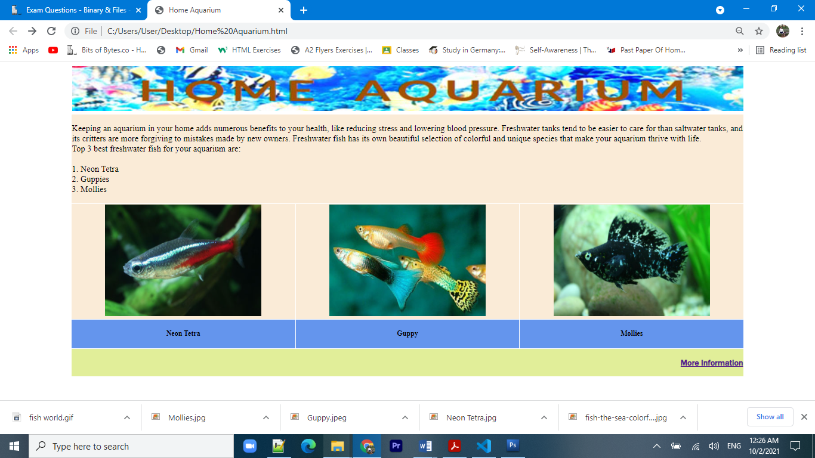

**Web Design Style Guide**

**Table**

• Create table to insert the image and text with width 90%.

• Five columns and three rows.

• No border line.

**Banner**

• Position the banner as shown on the wireframe. The banner image can be found in the

Home Aquarium folder.

**Background information**

• Position the text as shown on the wireframe. The text can be found as “background text” file in the folder.

• Text should be set to 'Lucida Sans', 'Lucida Sans Regular'.

• Color should be set to blueviolet color and font size is larger.

• The background color should be set to “antiquewhite” color.

• Don’t forget to make the break<br> as in the wireframe.

• Use unordered list.

**Images**

* + Insert the images.
  + Images can find in the given folder.
  + The background color should be set to “antiquewhite” color.

**Label Text**

* The background color should be set to “cornflowerblue” color.
* Text should be set to center align and h4 header style.

**Footer**

• Set the background colour rgb(225, 238, 153) and text colorto brown.

• Font is Franklin Gothic Medium font.

• Insert the text ‘More Information’.

• Style the text to be right align.